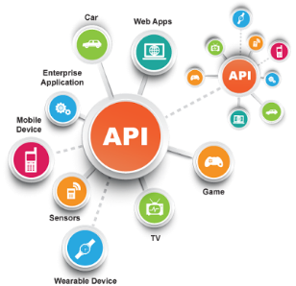**SE495 Software and Systems Integration**

**Developing a Serverless Newsletter Service**

**Project Description**

In this project, students will develop a basic serverless newsletter service using an integration platform as a service (iPaaS) provider like Zapier or IFTTT. The service will have the following functionality:

1. Connect to an email marketing service like Mailchimp to manage newsletter subscriptions
2. Connect to an RSS feed with latest tech news and save new articles
3. Trigger an action when a new article is posted to automatically send an email to all subscribers with the new article content
4. Use a serverless function to validate new subscriptions and prevent spam signups

**The high-level steps would be:**

1. Set up accounts with an iPaaS, email marketing and RSS feed service
2. Create a workflow to check the RSS feed on a schedule and save new articles
3. Create a workflow that is triggered when a new article is found to send an email to subscribers
4. Create a serverless function to validate new email addresses before subscribing
5. Test the full system to ensure new articles trigger emails as expected
6. Review and discuss concepts like microservices, containerization, serverless functions, security, etc.